SR UNIVERSITY
AI CODING
NAME: CHALLA.THANUSREE
ENROLLMENT NO:2403A54109
BATCH NO:04
ASSIGNMENT NO:4.2

Task Description#1
• Zero-shot: Prompt AI with only the instruction — Write a Python function to
generate the Fibonacci sequence up to n terms

Prompt
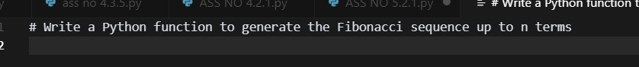

Code
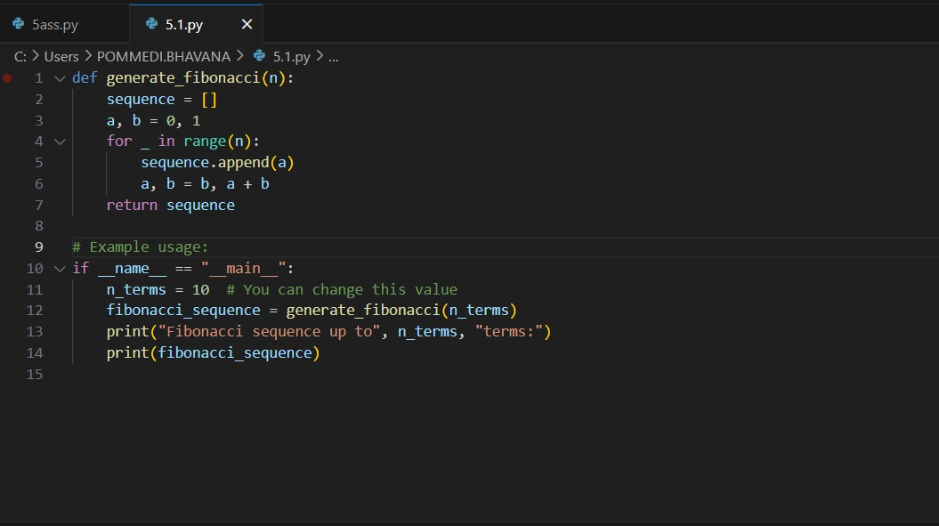

Output
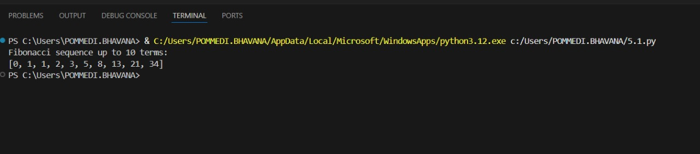

Explanation
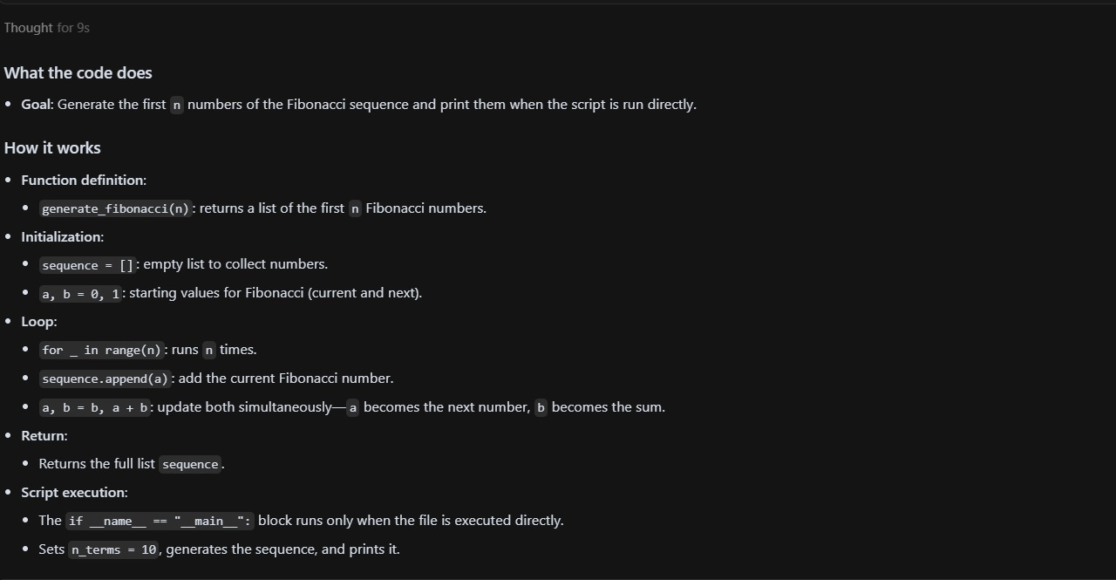
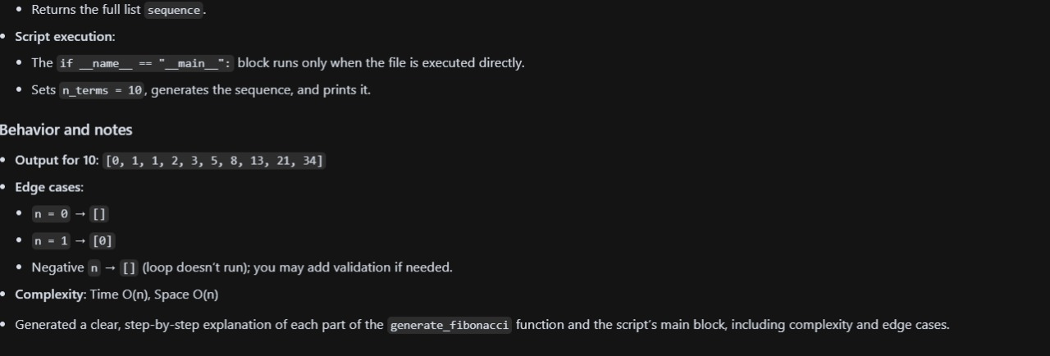

Task Description#2
• One-shot: Provide one example: Input: 100, Output: 37.78 to help AI generate a
function that converts Fahrenheit to Celsius.

Prompt
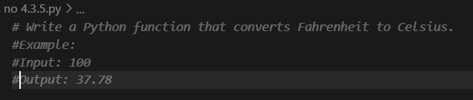

Code
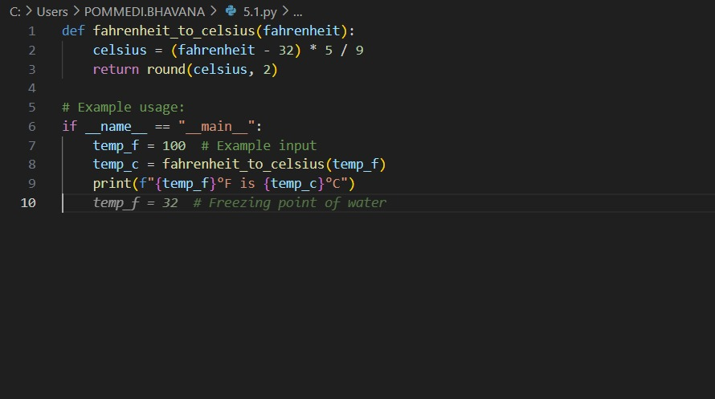

Output
Explanation
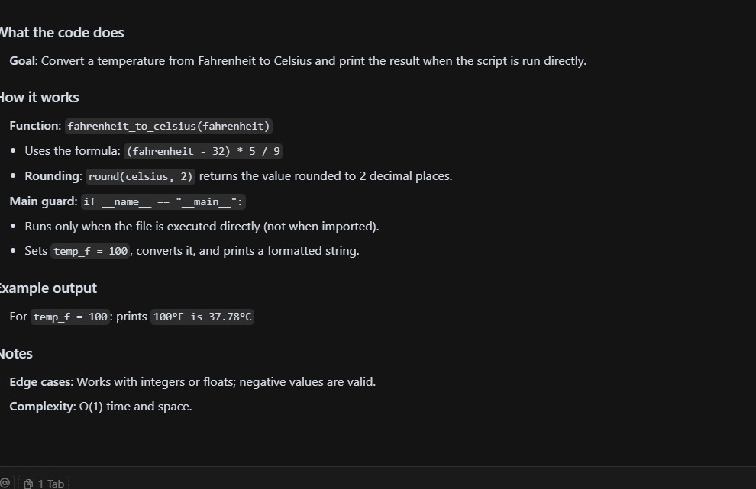

Task Description#3
• Few-shot: Give 2–3 examples to create a function that extracts the domain name from
an email address

Prompt
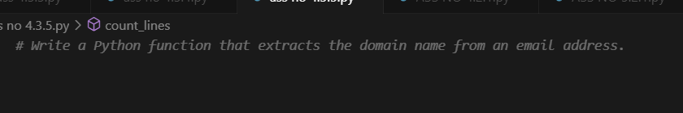

Code
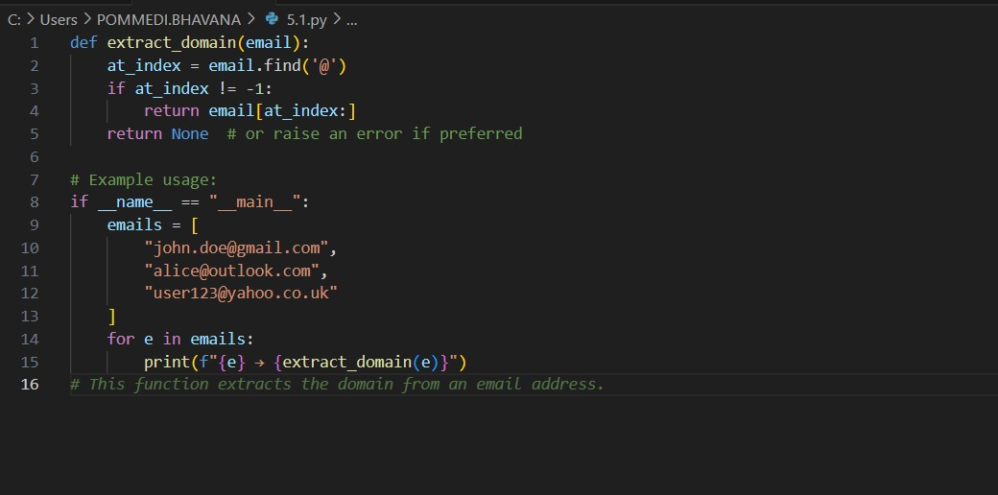

Output:
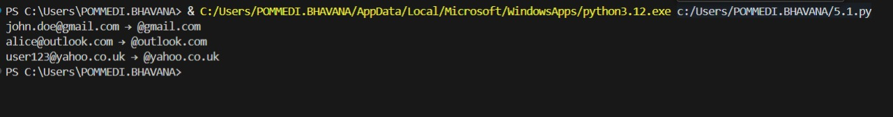

Explanation:
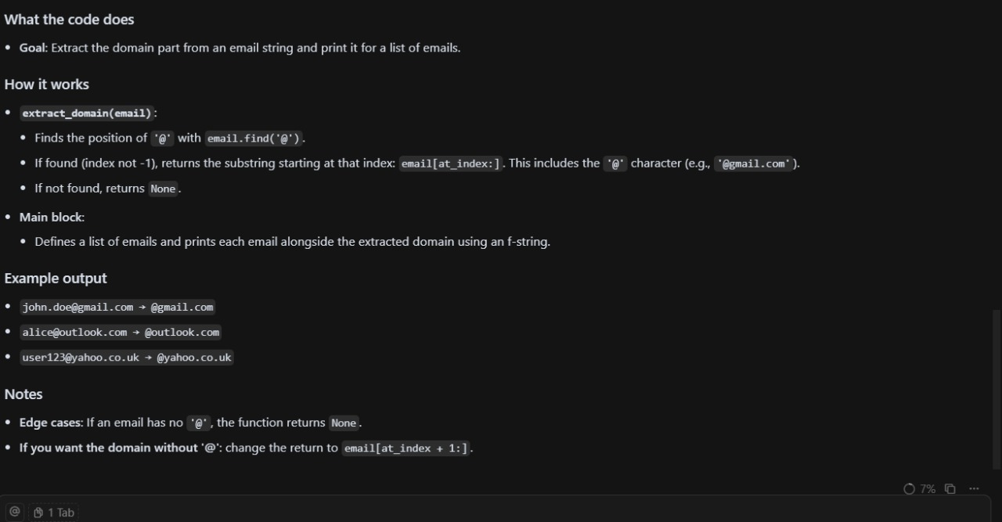

Task Description#4
• Compare zero-shot vs few-shot prompting for generating a function that checks
whether a word is a palindrome, ignoring punctuation and case.
Expected Output#4
• Output comparison + student explanation on how examples helped the model
Prompt:
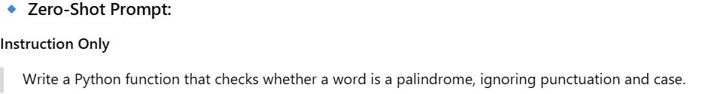
Code:
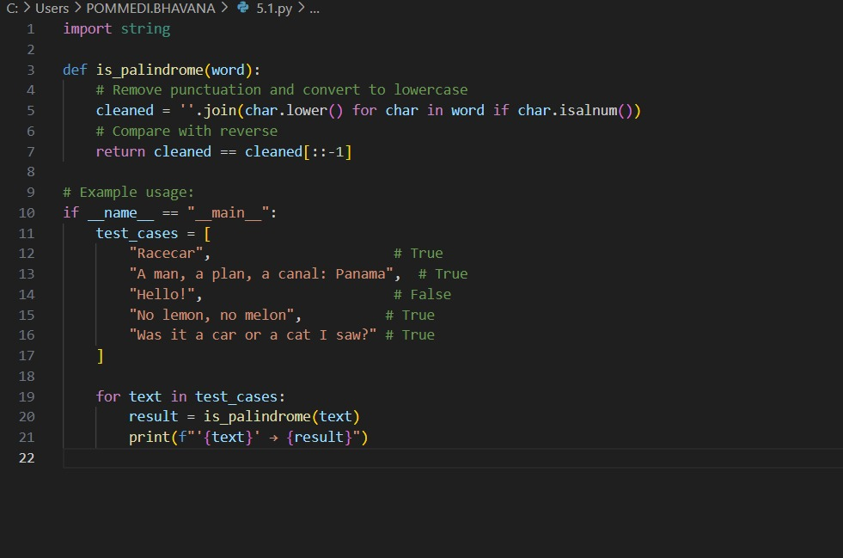

Output:
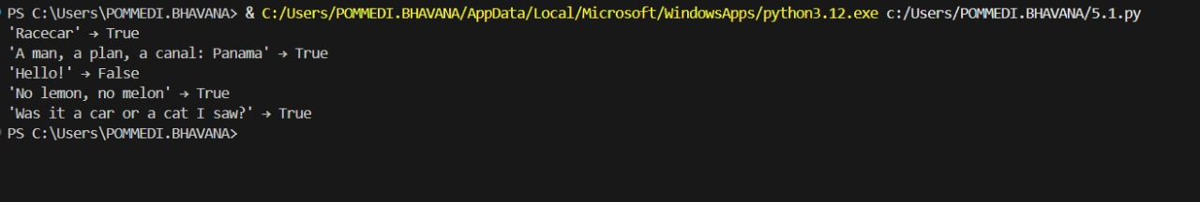
Explanation:

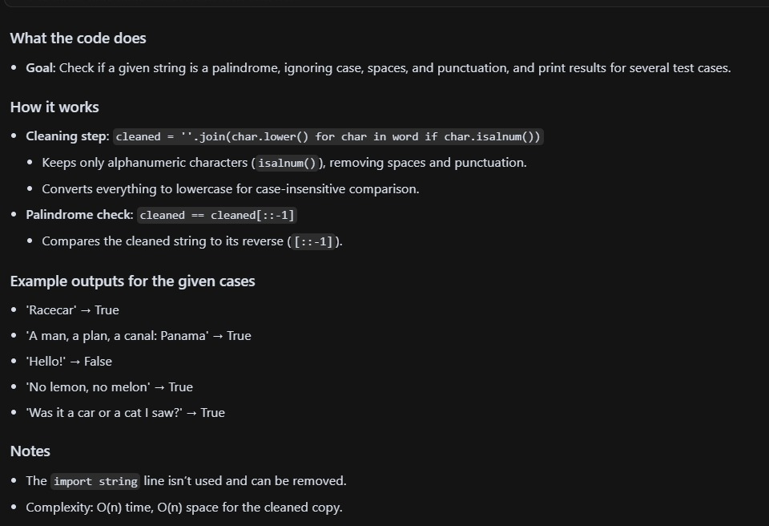

Task Description#5
• Use few-shot prompting with 3 sample inputs to generate a function that determines
the maximum of three numbers without using the built-in max() function.
Expected Output#5
• A function that handles all cases with correct logic based on example patterns
Prompt:
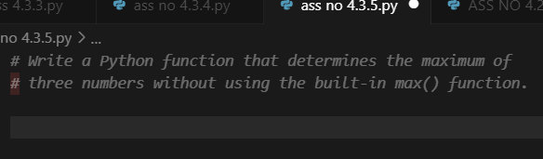
Code
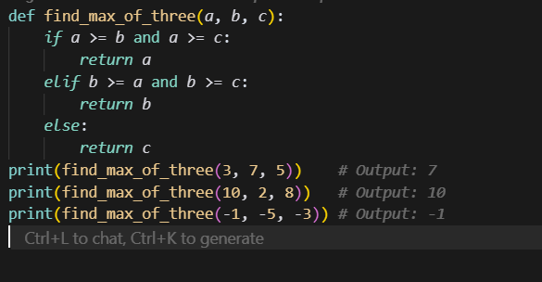
Out put
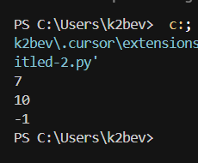
Explanation
